|  |
| --- |
| A.T.S studios |
| Space shooter with 3 levels and multiple bullets |
| **Game Design Document** |
| Version #2  All work Copyright © 2017 by Saftaral Studios.  All rights reserved. |
| **Safi Ullah Tanvir, Tarunjit Singh, Alnoor Sultan** |
|  |

|  |
| --- |
| 07th October, 2017 |

**Table of Contents**

Table of Contents

I. Game Overview 5

II. Game Play Mechanics 5

III. Camera 5

IV. Controls 5

V. Saving and Loading 5

VI. Interface Sketch 5

VII. Menu and Screen Descriptions 5

VIII. Game World 6

IX. Levels 6

X. Game Progression 6

XI. Characters 6

XII. Non-player Characters 6

XIII. Enemies 6

XIV. Weapons 6

XV. Items 6

XVI. Abilities 7

XVII. Vehicles 7

XVIII. Script 7

XIX. Scoring 7

XX. Puzzles/Mini-games 7

XXI. Bonuses 7

XXII. Cheat Codes 7

XXIII. Sound Index 7

XXIV. Story Index 7

XXV. Art / Multimedia Index 7

XXVI. Design Notes 8

XXVII. Future Features 8

# Game Overview

Player is flying a space ship armed with bullets and the goal is to destroy enemies to progress to next level.

# Game Play Mechanics

*There are 3 levels in this game. After successfully finishing each level, the player will progress to the next level. After moving up a level, player’s ship gets more bullets to fire at enemies.*

# Camera

*Camera angle utilized in our game is 2D.*

# Controls

*[Coming soon, TBD]*

# Saving and Loading

*N/A*

# Interface Sketch

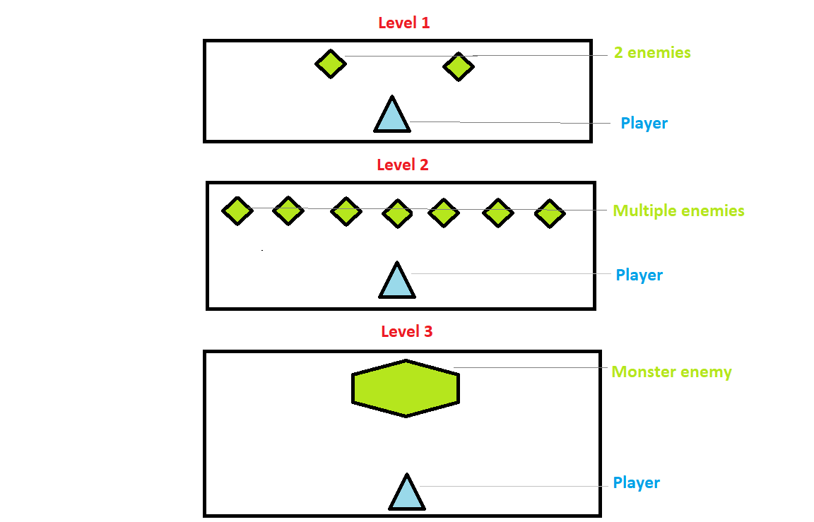

# Menu and Screen Descriptions

* *Start*
* *Help*
* *Exit*

# Game World

*[Coming soon]*

# Levels

*1st level: In this level, the player would fight 2 enemies. Player has 1 bullet type.*

*2nd level: Here, the player will face multiple enemies. Player gets dual bullet types.*

*3rd level: In the final level, player will face 1 large monster size enemy. Player will have multiple bullet types.*

# Game Progression

After finishing each level, the player is awarded more bullet types and advances to next level to face more difficult enemies.

* *Player*
* *Enemies (Different in 1st, 2nd and 3rd levels)*

|  |  |
| --- | --- |
| *Protagonist* | *Enemies* |
| *Level 1:* | *Level 1:* |
| *Level 2:* | *Level 2:* |
| *Level 3:* | *A picture containing indoor  Description generated with high confidenceLevel 3:* |

# Non-player Characters

N/A

# Enemies

First 2 levels will have smaller enemies.

The 3rd and final level will have 1 monster enemy.

# Weapons

Player will get more bullet types as each level is completed.

The type of bullets to be used: *[Coming soon]*

# Items

*N/A*

# Abilities

Player is able to move left and right, in order to avoid taking hit from enemies and pick a better position to shoot.

# Vehicles

Space ship will be the primary space craft used by player when playing.

# Script

[Coming soon, TBD]

# Scoring

[Coming soon, TBD]

# Puzzles/Mini-games

N/A

# Bonuses

N/A

# Cheat Codes

N/A

# Sound Index

[Coming soon]

# Story Index

[Coming soon]

# Art / Multimedia Index

[Coming soon]

# Design Notes

[Coming soon]

# Future Features

*N/A*